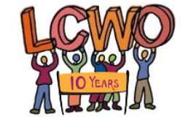

LOW CARBON WEST OXFORD
Selection criteria
Communications and Project Co-Ordinator
Essential
We are looking for a dynamic person who has the confidence and creativity to lead LCWO’s communications and to coordinate our carbon-reducing projects. The successful candidate will demonstrate the following skills and experience:

- Commitment to community-based action to address the climate emergency
- Ability to write effective communications for a range of media
- Ability to reach out for and work with volunteers
- Ability to work and communicate with a range of people and organisations
- ICT skills
- Sound administrative skills
- Commitment to diversity and equality issues

Desirable
- Experience of coordinating volunteers
- Experience of successful fundraising
- Experience of facilitating meetings/workshops
- Understanding of voluntary sector
- Resident in or near West Oxford

Final June 2024

